## logo ttwrdc.jpgTTWRDC(G) KHAMMAM

## DEPARTMENT OF PHYSICS

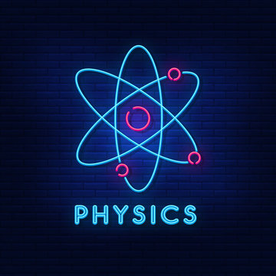

#### INDEX

|  |  |  |  |
| --- | --- | --- | --- |
| **S.NO** | **TOPICNAME** | **PAGE**  **NUMBERS** | |
| **FROM** | **TO** |
| **1** | **HISTORY OF THE DEPARTMENT** | **1** | **3** |
| **2** | **AIMS AND OBJECTIVES** | **4** | **5** |
| **3** | **VISION AND MISSION** | **5** | **6** |
| **4** | **SWOC ANALYSIS** | **6** | **7** |
| **5** | **TEACHING FACULTYAND THEIR PROFILES** | **8** | **10** |
| **6** | **CURRICULAR ASPECTS (CRITERIA –I)** | **11** | **18** |
| **7** | **TEACHING LEARNING AND EVALUATION(CRITERIA-II)** | **19** | **46** |
| **8** | **RESEARCH,CONSULTANCY AND TEACHING(CRITERIA-III)** | **47** | **50** |
| **9** | **INFRASTRUCTURE AND LEARNING RESOURCES(CRITERIA-IV)** | **51** | **60** |
| **10** | **STUDENTS SUPPORT AND PROGRESSION(CRITERIA-V)** | **61** | **62** |
| **11** | **GOVERNANCE,LEADERSHIP AND MANAGEMENT(CRITERIA-VI)** | **63** | **66** |
| **12** | **INSTITUTIONAL VALUES AND BEST PRACTICES(CRITERIA-VII)** | **67** | **68** |
| **13** | **SIGNIFICANT ACHIEVEMENTS** | **75** | **92** |
| **14** | **FUTURE PLAN** | **93** | **94** |

**INTRODUCTION**

* The Department of Physics was started in the year 2018 and mainly concentrates on introducing scientific methodology to rural students.
* This is systematically done by concept oriented learning with supporting experimental proofs.
* The department gives knowledge in Physics for undergraduate students as per Kakatiya University curriculum.
* The Department deals mostly with rural students the faculty works hard to Improve positive attitude and Scientific Temper among students
* Motivate students to go for higher studies in Physics.
* The department has a spacious Laboratory cum dark room. The department is having all the requirements to train the students both in theory and practicals
* The department has well trained and dedicated faculty.

#### AIMS AND OBJECTIVES

* The Department deals mostly with rural students the faculty works hard to Improve positive attitude and Scientific Temper among students
* Motivate students to go for higher studies in Physics.
* The department has a spacious Laboratory cum dark room. The department is having all the requirements to train the students both in theory and practicals
* The department has well trained and dedicated faculty.

## VISION AND MISSION

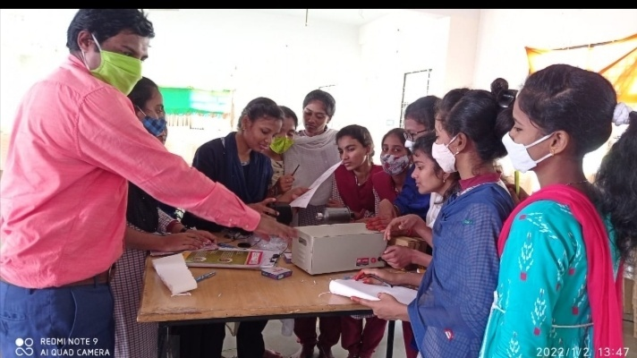

**Vision:**

* To awaken the young minds and discover their talents both in theory and in practical Physics through dedication to Teaching.
* To support the progression of students and igniting their minds to set their goal in a premier and prestigious institution.

**Mission:**

* To support the development activities of the college and make the department vibrant.
* To groom our students to become professionally and morally rich in Scientific Knowledge.
* To bring quality Education for effective Learning of the students.

#### STRENGTH,WEAKNESS,OPPORTUNITIES&CONSTRAINTS

**STRENGTHS**

1. Qualified & Experienced Faculty
2. Rich knowledge of Digital tools
3. Well equipped laboratories
4. Well ventilated lecture halls and

ambient college atmosphere

**WEAKNESSES**

1. Less faculty in the department.
2. Limited funding.
3. Lack of classrooms and laboratories.
4. Students are economically and socially poor.

**OPPORTUNITIES**

1. Research orientation
2. Exchange of knowledge through
3. Guest lectures and MoUs.
4. Choice Based Credit System (CBCS) enables students to learn subjects as per their choice.

**CHALLENGES**

1.Student’s transportation promoting to higher education due to

early age marriages

2. Collaboration with reputed organisations

## BIO-DATA OF THE STAFF

|  |  |  |  |
| --- | --- | --- | --- |
| **YEAR** | **NAME** | **DESIGNATION** | **PHOTO** |
| 2018-20 | M.NAGASRI | M.Sc., | https://www.ttwrdcs.ac.in/Khammam/gallery/f259521cc2d25f342375017f99925cc9.jfif |
| 2019-2024 | K.MANASA | M.Sc.,B.Ed,SET | MANASA |
|  |  |  |  |

**8**

|  |  |  |  |  |
| --- | --- | --- | --- | --- |
|  | **2020-24** | **B.HAREESH** | **M.Sc.,PGDIT,SET** | https://www.ttwrdcs.ac.in/Khammam/gallery/3b5f8f3a9945c001f07049136a41449b.jfif |
| 2022-23 | T.BHAVANI | M.Sc.,NET | https://www.ttwrdcs.ac.in/Khammam/gallery/e8545ba1d121d0bbcd8d2a4356c88aa2.jfif |
| 2023-24 | PRAVALIKA | M.Sc.,B.Ed | https://www.ttwrdcs.ac.in/Khammam/gallery/2222c50019cca6f9d6901eee62d44fe7.jfif |
| 2023-24 | N.MOUNIKA | M.Sc.,B.Ed | https://www.ttwrdcs.ac.in/Khammam/gallery/465c65a0d21a5684a45d76c2fdbed221.jpg |

**9**

**PRESENT WORKING STAFF**

|  |  |  |
| --- | --- | --- |
| **NAME** | **QUALIFICATION** | **PHOTO** |
| A.SWARNAKUMARI | M.Sc, B.ed, NET, | WhatsApp Image 2024-10-17 at 12.00.27 PM.jpeg |
| M.MANGAVENI | M.Sc., | WhatsApp Image 2024-10-25 at 2.43.04 PM.jpeg |

**CRITERIA-I CURRICULAR ASPECTS**

#### COURSESOFFERED

* At the inception of the college both MPC AND MPCS were introduced in English medium.

**Syllabus2016-2019Semesterwise**

## KAKATIYAUNIVERSITY,WARANGAL

## SCHEME FOR CHOICE BASED CREDITSYSTEM B.Sc. (PHYSICS)

**SEMESTERPATTERN**

|  |  |  |  |  |  |  |  |
| --- | --- | --- | --- | --- | --- | --- | --- |
| **YEAR** | **SEM** | **COURSE(PAPER)TITLEWITHCODE** | **COURSE TYPE\*** | **HRS/ WEEK** | **CREDITS** | MARKS | |
| Internal Assessment | SEM End Exam |
| **FIR**  **ST** | **I** | 101: Mechanics | DSC-1 | 4 | 4 | 20 | 80 |
| 101(P):Mechanics Lab(Pr) | DSC-1(P) | 3 | 1 | - | 25 |
| **II** | 201:Wavesand Oscillations | DSC-2 | 4 | 4 | 20 | 80 |
| 201(P):Waves and Oscillations Lab (Pr) | DSC-2(P) | 3 | 1 | - | 25 |
| **SECO**  **ND** | **III** | 301:ThermalPhysics | DSC-3 | 4 | 4 | 20 | 80 |
| 301(P): Thermal Physics Lab(Pr) | DSC-3(P) | 3 | 1 | - | 25 |
| **IV** | 401: Optics | DSC-4 | 4 | 4 | 20 | 80 |
| 401(P):Optics Lab(Pr) | DSC-4(P) | 3 | 1 | - | 25 |
| **THIRD** | **V** | 501:Electromagnetism | DSC-5 | 3 | 3 | 15 | 60 |
| 501(P):Electromagnetism Lab(Pr) | DSC-5(P) | 3 | 1 | - | 25 |
| 502:Elective(Theory)–1(A/B/C)   1. Solid state physics 2. Modern Optics | DSE-1 | 3 | 3 | 15 | 60 |
| 502(P):Elective(Practical)-1(A/B/C)   1. Solid state physics Lab 2. Modern Optics Lab | DSE-1(P) | 3 | 1 | - | 25 |
| **VI** | 601:ModernPhysics | DSC-6 | 3 | 3 | 15 | 60 |
| 601(P):Modern PhysicsLab(Pr) | DSC-6(P) | 3 | 1 | - | 25 |
| 602:Elective(Theory)–2(A/B/C)   1. Basic Electronics 2. Physics of Semiconductor devices | DSE-2 | 3 | 3 | 15 | 60 |
| 602(P):Elective(Practical)–2(A/B/C)   1. Basic Electronics Lab 2. Physics of Semiconductor devices Lab | DSE-2(P) | 3 | 1 | - | 25 |
|  |  | **Total** |  |  | **36** | 140 | 760 |
| GrandTotal:900 | |

*DSC: Discipline Specific Course (Core) DSE: Discipline Specific Elective(Elective)

## PAPERS AND CREDITS

## B.Sc.(PHYSICS)

## KAKATIYAUNIVERSITY,WARANGAL

**SUMMARY OF CREDITS**

|  |  |  |  |  |  |  |
| --- | --- | --- | --- | --- | --- | --- |
| **SEM** | **CourseType\*** | **Credits/M arks (Theory) (Internal**  **+Sem End Exam)** | **HPW**  **(Theory)** | **Credits/ Marks (Practical)** | **HPW**  **(Practical)** | **Deptworkload per week per section** |
| I | DSC- Core | 4 /(20+80) | 4 | 1/25 | 3 | 6 |
| II | DSC- Core | 4 /(20+80) | 4 | 1/25 | 3 | 6 |
| III | DSC- Core | 4 /(20+80) | 4 | 1/25 | 3 | 6 |
| IV | DSC- Core | 4 /(20+80) | 4 | 1/25 | 3 | 6 |
| V | DSC- Core | 3 /(15+60) | 3 | 1/25 | 3 | 5 |
| DSE-Elective(A/B) | 3 /(15+60) | 3 | 1/25 | 3 | 5 |
| VI | DSC- Core | 3 /(15+60) | 3 | 1/25 | 3 | 5 |
| DSE-Elective(A/B) | 3 /(15+60) | 3 | 1/25 | 3 | 5 |
|  | **Total** | **28 /700** | **28** | **8 /200** | **24** | **52** |

*DSC: Discipline Specific Course, DSE: Discipline Specific Elective

### COURSEOUTCOMES

The Outcomes of UG Course, B.Sc. in Physics   
After completion of B. Sc. in Physics students are able to:

Demonstrate a rigorous understanding of the core theories & principles of physics, which includes mechanics, electromagnetism, thermodynamics, & quantum mechanics.

* Learn the Concepts as Quantum Mechanics, Relativity, introduced at degree level in order to understand nature at atomic levels.
* Provide knowledge about material properties and its application for developing technology to ease the problems related to the society.
* Understand the set of physical laws, describing the motion of bodies, under the influence of system of forces.
* Understand the relationship between particles & atom, as well as their creation & decay.
* Relate the structure of atoms & subatomic particles
* Understand physical properties of molecule the chemical bonds between atom as well as molecular dynamics.
* Analyze the applications of mathematics to the problems in physics & develop suitable mathematical method for such application & for formulation of physical theories.
* Learn the structure of solid materials & their different physical properties along with metallurgy, cryogenics, electronics, & material science.
* Understand the fundamental theory of nature at small scale & levels of atom & sub-atomic particle.

P-III: ELECTRCITY AND MAGNETISM (Credits: 07, Theory-04, Practicals-03)

**Course learning outcome**: After going through the course, the student should be able to Demonstrate

* Gauss law, Coulomb’s law for the electric field, Demonstrate Gauss law, Coulomb’s law for the electric field, and apply it to systems of point charges as well as line, surface, and volume distributions of charges.
* Explain and differentiate the vector (electric fields, Coulomb’s law) and scalar (electric potential, electric potential energy) formalisms of electrostatics.  Apply Gauss’s law of electrostatics to solve a variety of problems.
* Articulate knowledge of electric current, resistance and capacitance in terms of electric field and electric potential.  Demonstrate a working understanding of capacitors.
* Describe the magnetic field produced by magnetic dipoles and electric currents.
* Explain Faraday-Lenz and Maxwell laws to articulate the relationship between electric and magnetic fields.  Understand the dielectric properties, magnetic properties of materials and the phenomena of electromagnetic induction.  Describe how magnetism is produced and list examples where its effects are observed.
* Apply Kirchhoff’s rules to analyze AC circuits consisting of parallel and/or series combinations of voltage sources and resistors and to describe the graphical relationship of resistance, capacitor and inductor.
* Apply various network theorems such as Superposition, Thevenin, Norton, Reciprocity, Maximum Power Transfer, etc. and their applications in electronics, electrical circuit analysis, and electrical machines.
* In the laboratory course the student will get an opportunity to verify various laws in electricity and magnetism such as Lenz’s law, Faraday’s law and learn about the construction, working of various measuring instruments.
* Should be able to verify of various circuit laws, network theorems elaborated above using simple electric circuits.
* (X) **Skills to be learned**: This course will help in understanding basic concepts of electricity and magnetism and their applications.  Basic course in electrostatics will equips the student with required prerequisites to understand electrodynamics phenomena.

P-IV: WAVES AND OPTICS

**(Credits: 07, Theory-04, Practicals-03)**

**Course learning outcome**: This course will enable the student to

1. Recognize and use a mathematical oscillator equation and wave equation, and derive these equations for certain systems.
2. Apply basic knowledge of principles and theories about the behaviour of light and the         physical environment to conduct experiments.
3. Understand the principle of superposition of waves, so thus describe the formation of standing waves.
4. Explain several phenomena we can observe in everyday life that can be explained as wave phenomena.
5. Use the principles of wave motion and superposition to explain the Physics of polarisation, interference and diffraction.  Understand the working of selected optical instruments like biprism, interferometer, diffraction grating, and holograms.
6. In the laboratory course, student will gain hands-on experience of using various optical instruments and making finer measurements of wavelength of light using Newton Rings experiment, Fresnel Biprism etc.
7. Resolving power of optical equipment can be learnt firsthand.

TIMETABLE2023-24

|  |  |  |  |  |  |  |  |  |  |
| --- | --- | --- | --- | --- | --- | --- | --- | --- | --- |
| **TTWRDC(G)-Khammam** | | | | | | | | | |
| **Department Of Physics** | | | | | | | | | |
| **TIME TABLE for the Academic Year-2023-2024** | | | | | | | | | |
| DAY/TIME | 9:00-10:00 | 10:00-11:00 | 11:00-11:15 | 11:15-12:15 | 12:15-1:15 | 1:15-2:15 | 2:15-3:15 | 3:15-3:30 | 3:30-5:00 |
| MON | II-MPC II-MPCs  III-MPCs  III-MPC |  | BREAK |  | I-MPC&MPCs | LUNCH BREAK |  | BREAK | PG Coaching/ Employbility Skils |
| TUE | II-MPC II-MPCs  III-MPCs  III-MPC |  |  | I-MPC&MPCs | III-MPCs&III MPC PHYSICS LAB | PG Coaching/ Employbility Skils |
| WED | II-MPC II-MPCs |  |  | I-MPC&MPCs | PHYSICS LAB  III-MPCs&III MPC | PG Coaching/ Employbility Skils |
| THU | II-MPC II-MPCs |  |  | I-MPC&MPCs | PHYSICS LAB  III-MPCs&III MPC | PG Coaching/ Employbility Skils |
| FRI | II-MPCs  II-MPC III-MPCs  III-MPC |  |  | I-MPC&MPCs | PHYSICS LAB  I-MPC&MPCs | PG Coaching/ Employbility Skils |
| SAT | III-MPC III-MPCs  II-MPC&MPCs  I-MPC&MPCs |  |  | I-MPC&MPCs | PHYSICS LAB II-MPCs  II-MPC | PG Coaching/ Employbility |

|  |  |  |  |  |  |  |  |  |  |
| --- | --- | --- | --- | --- | --- | --- | --- | --- | --- |
| **TTWRDC(w)-Khammam** | | | | | | | | | |
| **Department Of Physics** | | | | | | | | | |
| **TIME TABLE for the Academic Year-2022-2023** | | | | | | | | | |
| DAY/TIME | 9:00-10:00 | 10:00-11:00 | 11:00-11:15 | 11:15-12:15 | 12:15-1:15 | 1:15-2:15 | 2:15-3:15 | 3:15-3:30 | 3:30-5:00 |
| MON | II-MPC II-MPCs  III-MPCs  III-MPC |  | BREAK |  | I-MPC&MPCs | LUNCH BREAK |  | BREAK | PG Coaching/ Employbility Skils |
| TUE | II-MPC II-MPCs  III-MPCs  III-MPC |  |  | I-MPC&MPCs | III-MPCs&III MPC PHYSICS LAB | PG Coaching/ Employbility Skils |
| WED | II-MPC II-MPCs |  |  | I-MPC&MPCs | PHYSICS LAB  III-MPCs&III MPC | PG Coaching/ Employbility Skils |
| THU | II-MPC II-MPCs |  |  | I-MPC&MPCs | PHYSICS LAB  III-MPCs&III MPC | PG Coaching/ Employbility Skils |
| FRI | II-MPCs  II-MPC III-MPCs  III-MPC |  |  | I-MPC&MPCs | PHYSICS LAB  I-MPC&MPCs | PG Coaching/ Employbility Skils |
| SAT | III-MPC III-MPCs  II-MPC&MPCs  I-MPC&MPCs |  |  | I-MPC&MPCs | PHYSICS LAB II-MPCs  II-MPC | PG Coaching/ Employbility Skils |

|  |  |  |  |  |  |  |  |  |  |
| --- | --- | --- | --- | --- | --- | --- | --- | --- | --- |
| **TTWRDC(w)-Khammam** | | | | | | | | | |
| **Department Of Physics** | | | | | | | | | |
| **TIME TABLE for the Academic Year-2021-2022** | | | | | | | | | |
| DAY/TIME | 9:00-10:00 | 10:00-11:00 | 11:00-11:15 | 11:15-12:15 | 12:15-1:15 | 1:15-2:15 | 2:15-3:15 | 3:15-3:30 | 3:30-5:00 |
| MON | II-MPC II-MPCs |  |  |  |  |  |  |  |  |

**FACULTYWISEWORKLOAD**

|  |  |  |  |  |
| --- | --- | --- | --- | --- |
| **S.NO** | **NAMEOFTHE**  **FACULTY** | **THEORY**  **HOURS** | **PRACTICAL**  **HOURS** | **TOTAL** |
| **1** | **A.SWARNA**  **KUMARI** | **12** | **06** | **18** |

**GRANDTOTALHOURSPER WEEK- 18**

|  |  |  |  |  |
| --- | --- | --- | --- | --- |
| **S.NO** | **NAMEOFTHE**  **FACULTY** | **THEORY**  **HOURS** | **PRACTICAL**  **HOURS** | **TOTAL** |
| **1** | **M.MANGA VENI** | **12** | **06** | **18** |

**GRANDTOTALHOURSPER WEEK- 18**

# CRITERIA-II

# TEACHING AND LEARNING

**AND EVALUATION**

The department have been regularly conducting the following activities.

* Fieldtrips
* Student classroom seminars
* Quiz programs
* Group discussion
* Student assignments
* Extension Lectures

**Academic plan**

**Faculty member prepares a teaching plan as per syllabus and Almanac of Kakatiya University**

**Digital Teaching Dairy**

**Digital Teaching Diary is the part of CAIMS**

**(College Administration Information Management System)**

**Specialized using ICT Tools**

**Department faculty trained in ICT tools. ICT enabled teaching is being done in blended modes through different platforms..**



**Internal & External**

**Examinations**

**Department following time to time guidelines of the university in conducting Internal examinations. Results will be uploaded in the University website.**

**Faculty Learning & Development**

**Faculty are actively participating in Seminars, Workshops. They are stringent in completion of FDP and RC .**

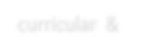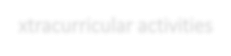

Co- curricular & Extracurricular activities

1. **EXPERIMENTAL LEARNING:**  **06**

**01. QUIZ & ASSIGNMENTS**

**Objectives:**



**01** It increases thinking ability , Knowledge,

response speed & Listening Skills.

1. **FIELD & IIDUSTRY**

**TRIPS 05**

**02. STUDENT SEMINARS:**

**Objectives:**

**02**

Increases public speaking skills Decreases inferiority complex

Builds up self-confidence in students. Deep understanding of the topic.

Improve communication skills.

1. **ICT Classes**

**04**

**03 PG Entrance Coaching:**

Objectives:

To orient the students to pursue Higher education.

|  |  |  |  |  |  |  |
| --- | --- | --- | --- | --- | --- | --- |
|  |  |  |  |  |  |  |

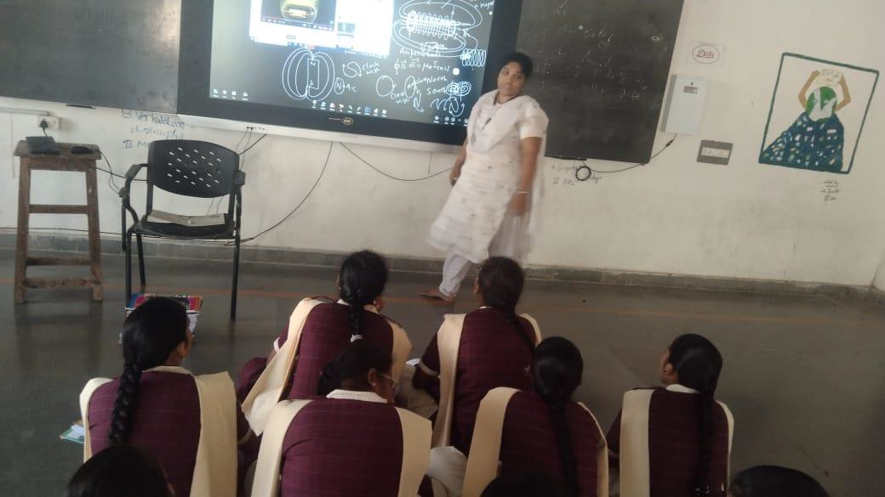**ICT TOOL FOR EFFECTIVE TEACHING IN CLASSROOM**

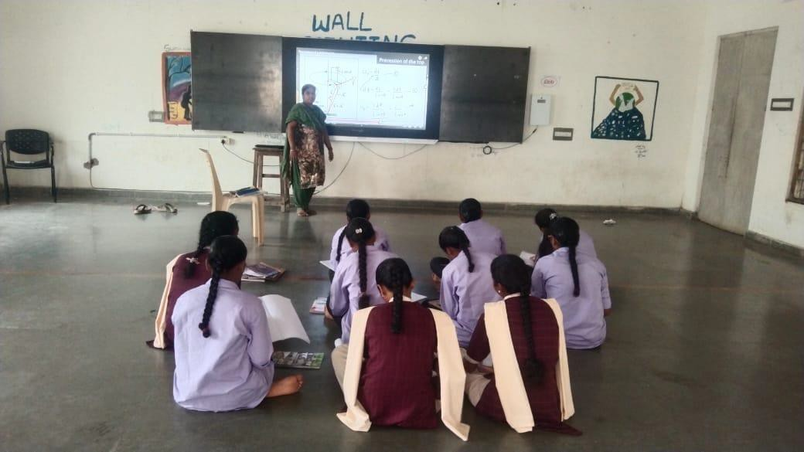

#### STUDENT ENROLLMENT& PROFILE

|  |  |  |  |  |  |  |  |  |  |  |  |  |  |  |  |  |  |  |  |  |  |  |  |  |  |  |
| --- | --- | --- | --- | --- | --- | --- | --- | --- | --- | --- | --- | --- | --- | --- | --- | --- | --- | --- | --- | --- | --- | --- | --- | --- | --- | --- |
| |  |  |  | | --- | --- | --- | | YEAR | MPC | MPCS | | 2018-19 | 25 | 25 | | 2019-20 | 25 | 36 | | 2020-21 | 28 | 30 | | 2021-22 | 22 | 22 | | 2022-23 | 29 | 12 | | 2023-24 | 8 | 5 | | 2024-25 | 0 | 15 | |  |  |
|  |  |  |
|  |  |  |
|  |  |  |
|  |  |  |
|  |  |  |
|  |  |  |
|  |  |  |

**RESULTANALYSIS–YEARWISE**

**2018-21**

|  |  |  |  |
| --- | --- | --- | --- |
|  | APPEARED | PASSED | PERCENTAGE |
| SEM1 | 50 | 50 | 100 |
| SEM2 | 50 | 50 | 100 |
| SEM3 | 49 | 49 | 100 |
| SEM4 | 48 | 48 | 100 |
| SEM5 | 48 | 48 | 100 |
| SEM6 | 49 | 49 | 100 |
|  |  |  |  |

**2019-22**

|  |  |  |  |  |
| --- | --- | --- | --- | --- |
|  | APPEARED | PASSED | PERCENTAGE | |
| SEM1 | 58 | 58 | 100 |  |
| SEM2 | 58 | 58 | 100 |  |
| SEM3 | 58 | 58 | 100 |  |
| SEM4 | 58 | 53 | 91.3 |  |
| SEM5 | 58 | 58 | 100 |  |
| SEM6 | 58 | 52 | 89.6 |  |
|  |  |  |  |  |

2020-23

|  |  |  |  |
| --- | --- | --- | --- |
|  | APPEARED | PASSED | PERCENTAGE |
| SEM1 | 53 | 48 | 90.5 |
| SEM2 | 57 | 53 | 92.9 |
| SEM3 | 48 | 46 | 95.8 |
| SEM4 | 48 | 48 | 100 |
| SEM5 | 49 | 49 | 100 |
| SEM6 | 49 | 49 | 100 |
|  |  |  |  |

2021-24

|  |  |  |  |  |
| --- | --- | --- | --- | --- |
|  | APPEARED | PASSED | PERCENTAGE | |
| SEM1 | 51 | 51 | 100 |  |
| SEM2 | 50 | 49 | 98 |  |
| SEM3 | 51 | 50 | 98 |  |
| SEM4 | 50 | 48 | 96 |  |
| SEM5 | 51 | 50 | 98 |  |
| SEM6 | 49 | 49 | 100 |  |

**PIONEERSOFTHEDEPARTMENT**

* **Name of the Lecturer: M.NAGASRI M.Sc.**
* **Year of joining :2018**
* **Name of the Lecturer: K.MANASA .M.Sc. Year of joining in department:2019**
* **Name of the Lecturer: B.HAREESH**
* **joining in department:2019**

**The staff members presently working in the department**

* + **Name of the lecturer: A.SWARNAKUMARI .M.Sc., B.Ed, NET**
  + **YearofjoininginDepartment:2024**
  + **Name of the lecturer: M.MANGA VENI M.Sc.,**
  + **YearofjoininginDepartment:2024**

**Number of Teaching Posts Sanctioned**

* + **One regular post and one guest post**

|  |  |  |  |  |
| --- | --- | --- | --- | --- |
| **NAME OF**  **THE LECTURER** | **Qualification** | **Designation** | **Specialization** | **Exp.in years** |
| **Smt.**  **A.SWARNAKUMARI** | **M.Sc.**  **B.Ed,NET** | **Regular** | **---SOLID STATE PHYSICS----** | **16** |
| **M.MANGAVENI** | **M.Sc.,** | **Guest** | **--------** | **3** |
|  |  |  |  |  |

The department have been regularly conducting the following activities.

* Fieldtrips
* Student classroom seminars
* Quiz programs
* Group discussion
* Student assignments
* Extension Lectures

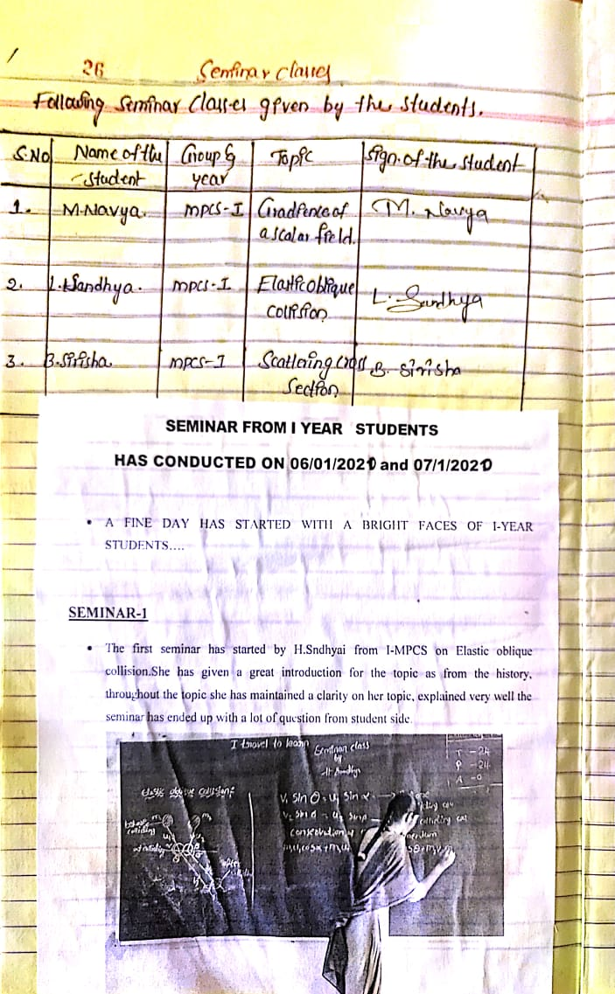

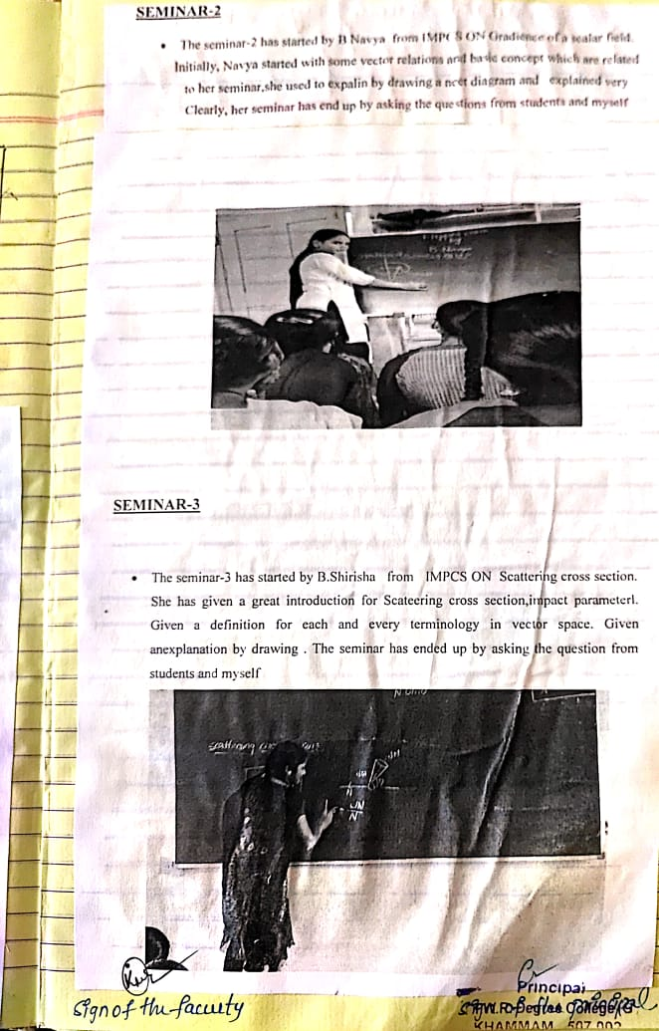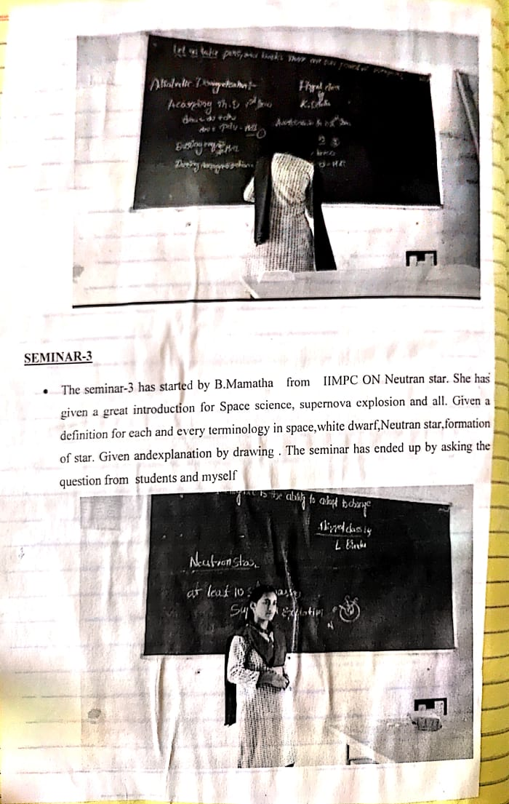

DEBATE TOPIC: NUCLEAR ENERGY IS GOOD OT NOT??

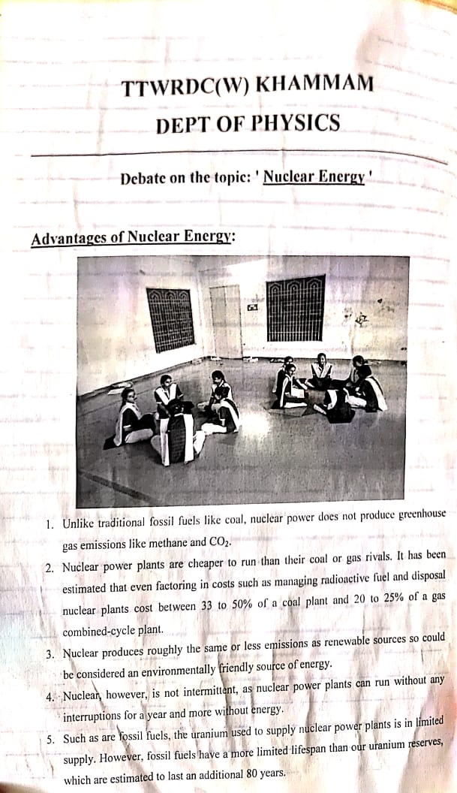

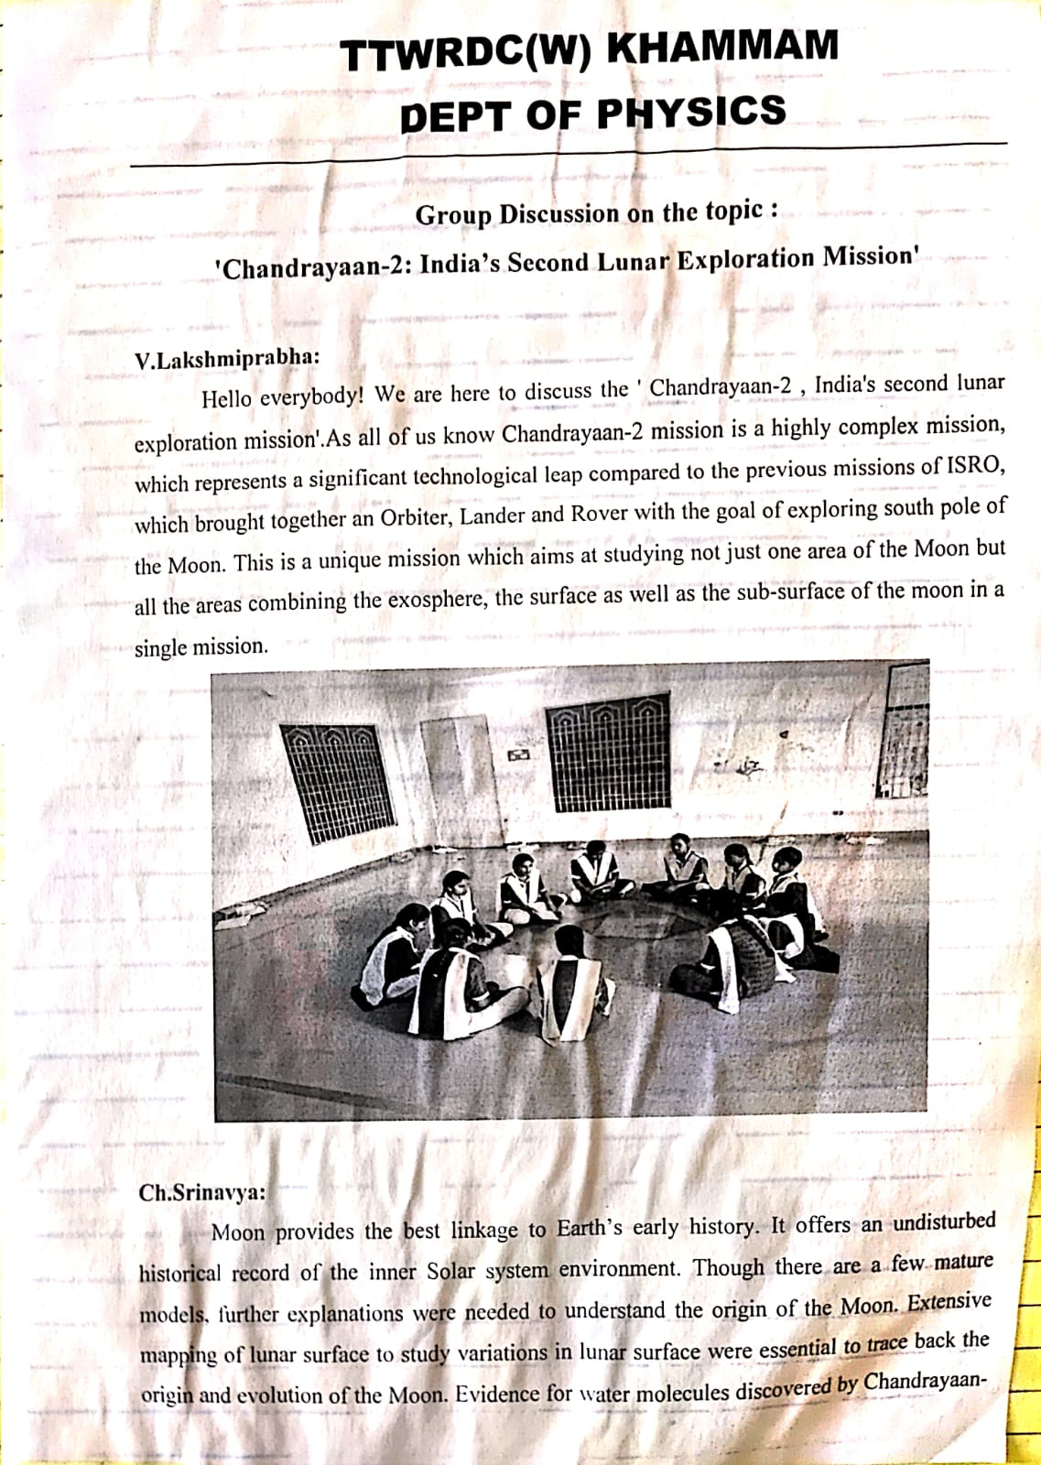

**GROUP DISCUSSION** 

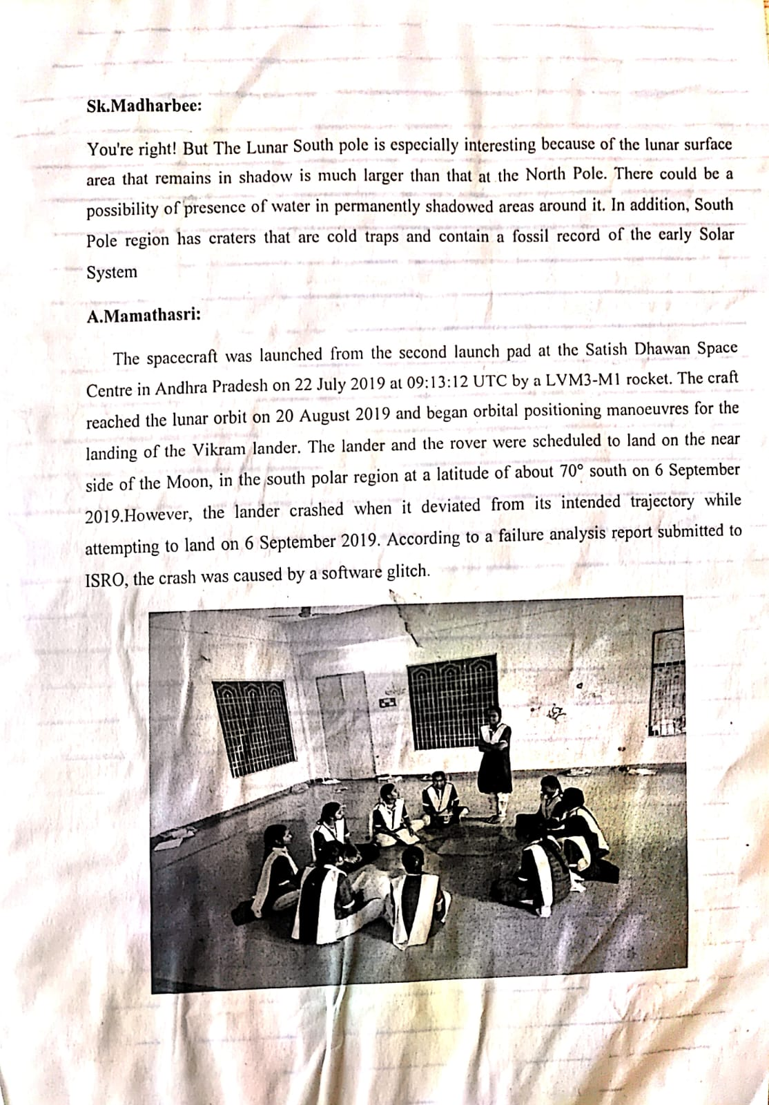

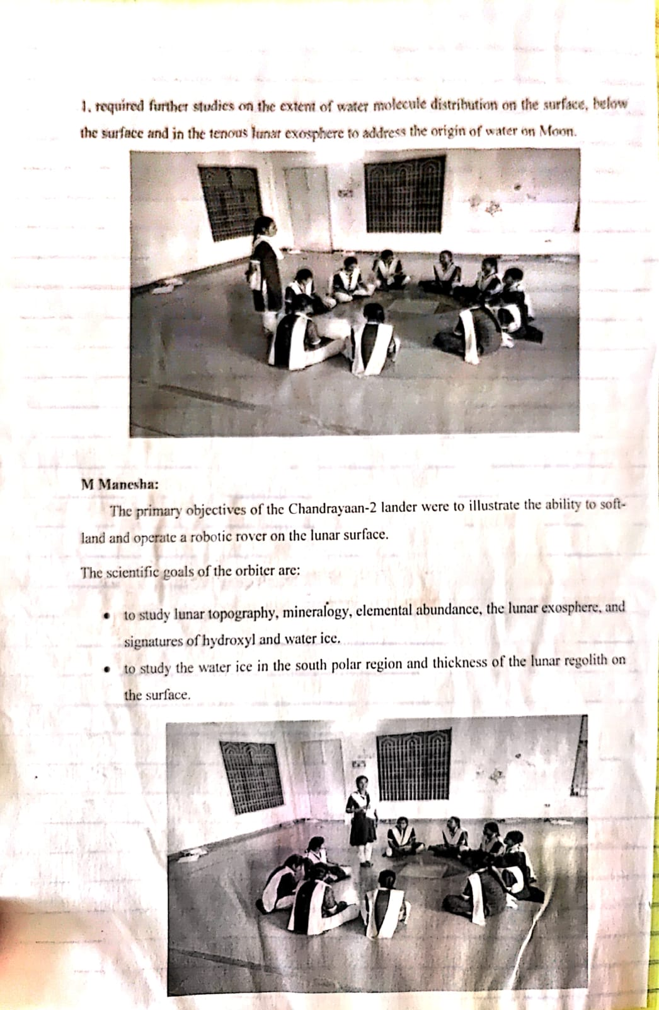

**ICT TOOLS USED WHILE LEARNING**

# CRITERIAIII

**RESEARCH AND INNOVATION AND EXTENSION ACTIVITIES.**

**EXTENSION LECTURES**

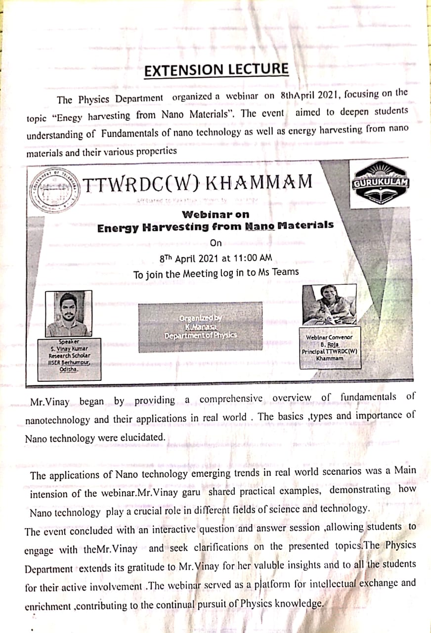

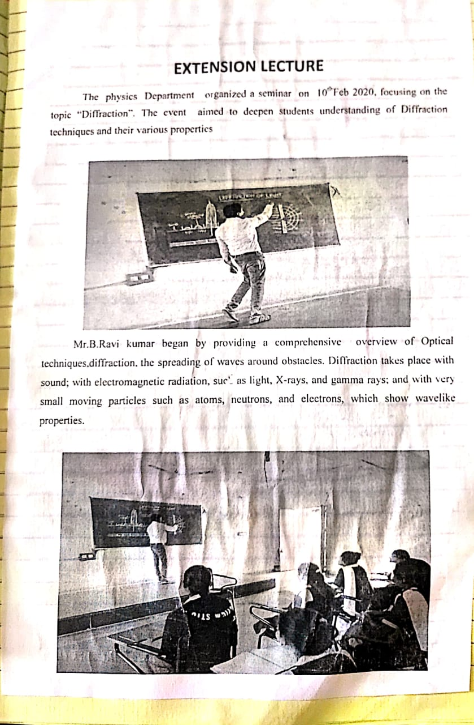



# CRITERIA –IV INFRASTRUCTUREANDLEARNINGRESOURCES

**LABORATORY&EQUIPMENT**

# B.Sc.(Physicspracticals)–Iyear Semester - I

## Paper–I::MechanicsPracticals

1. Measurement oferrors –simple Pendulum.
2. Calculation of slope and intercept of a Y= mX +C graph by theoreticalmethod (simplependulum experiment)
3. Studyofacompoundpendulum-determination o f„g‟and„k‟.
4. Y‟byuniformBending
5. Y byNon-uniformBending.
6. MomentofInertiaof aflywheel.
7. RigiditymodulibytorsionPendulum.
8. Determinesurfacetension ofaliquidthroughcapillaryrise method.
9. DeterminationofSurface Tension ofaliquid by anyother method.
10. DetermineofViscosityof a fluid.

# B.Sc.(PhysicsPracticals)–Iyear Semester - II

## Paper–II::WavesandOscillationsPracticals

1. Studyof dampingof an oscillatingdisc in Air andWaterlogarithmic decrement.
2. Studyof Oscillations under Bifilar suspension-Verification ofaxis theorems
3. Studyof oscillations of amass under different combinationofsprings-Series andparallel.
4. Verificationof Lawsofa stretchedstring(Three Laws).
5. Determinationoffrequencyofabar-Melde‟sexperiment.
6. ObservationofLissajousfiguresfromCRO-Frequencyratio.Amlitudeandphasedifferenceof two waves.
7. Volume Resonator–determination offrequencyof atuning fork.
8. Velocityof Transverse wavealongastretched string.
9. Studyofdampingofabarpendulum-dampingfactor
10. Studyof coupledoscillator-resonance

# B.Sc.(PhysicsPracticals)–IIyear Semester - III

## Paper–III::ThermalPhysics Practicals

1. Co-efficientofthermalconductivityofabadconductorbyLee‟smethod.
2. MeasurementofStefan‟sconstant.
3. SpecificheatofaliquidbyapplyingNewton‟slawofcoolingcorrection.
4. Heatingefficiencyof electricalkettlewith varyingvoltages.
5. Calibrationofthermocouple
6. CoolingCurveofametallic body
7. Resistancethermometer
8. Thermalexpansionofsolids
9. Studyofconversionofmechanicalenergytoheat.
10. DeterminetheSpecificofasolid( graphiterod)

# B.Sc.(PhysicsPracticals)–IIyear Semester - IV

## Paper–IV::Optics Practicals

1. Thickness of awireusingwedge method.
2. Determinationofwavelengthoflight usingBiprism.
3. DeterminationofRadiusofcurvatureofagivenconvexlensbyformingNewton‟srings.
4. Resolvingpower of grating.
5. Studyofopticalrotation-polarimeter.
6. Dispersivepower ofaprism
7. Determinationofwavelengthoflightusingdiffractiongratingminimumdeviationmethod.
8. Wavelengthoflightusingdiffraction grating–normalincidence method.
9. Resolvingpower ofatelescope.
10. Refractiveindexofaliquidandglass(BoysMethod).
11. Pulfrichrefractometer–determinationofrefractiveindexofliquid.
12. WavelengthofLaserlightusingdiffractiongrating.

# B.Sc.(PhysicsPracticals)–IIIyear Semester - V

## Paper– V::ElectromagnetismLab

PHYSICS LABORATORY

* 1. To verifythe Thevenin Theorem
  2. ToverifyNorton Theorem
  3. To verifySuperposition Theorem
  4. Toverifymaximum power transfer theorem.
  5. TodetermineasmallresistancebyCareyFoster‟s bridge.
  6. Todeterminethe(a)currentsensitivity,(b)chargesensitivity,and(c)CDRofaB.G.
  7. Todeterminehigh resistancebyleakagemethod.
  8. TodeterminetheratiooftwocapacitancesbyDeSauty‟sbridge.
  9. Todetermineself-inductanceofacoilbyAnderson‟sbridgeusingAC.
  10. Todetermineself-inductanceofacoilbyRayleigh‟smethod.
  11. TodeterminecoefficientofMutual inductancebyabsolute method.

# B.Sc.(PhysicsPractical)–IIIyear Semester - V

**Paper:VI(A)SolidState Physics**

1. Measurementofsusceptibilityof paramagnetic solution(Quinck`sTubeMethod)
2. TomeasuretheMagneticsusceptibilityofSolids(Guoy‟smethod)
3. TodeterminetheCouplingCoefficientof aPiezoelectric crystal.
4. Tomeasurethe DielectricConstantofadielectricMaterialswith frequency
5. Tostudythe polarization-electricfield(P-E)hysteresisloopof aFerroelectric Crystal.
6. Todraw theB-Hcurveof FeusingSolenoid& determineenergyloss from Hysteresis.
7. Tomeasuretheresistivityofasemiconductor(Ge)withtemperaturebyfour-probemethod(room temperature to 150oC) and to determine its band gap.
8. TodeterminetheHall coefficientofasemiconductor sample.
9. Calculationofd-valuesofagivenLaue‟spattern.
10. Calculationofd-valuesofpowerdiffraction method.
11. Tostudythe spectralcharacteristicsofaPhoto-Voltaiccell.
12. .VerificationofBragg‟sequation.

**LISTOF EQUIPMENTS**

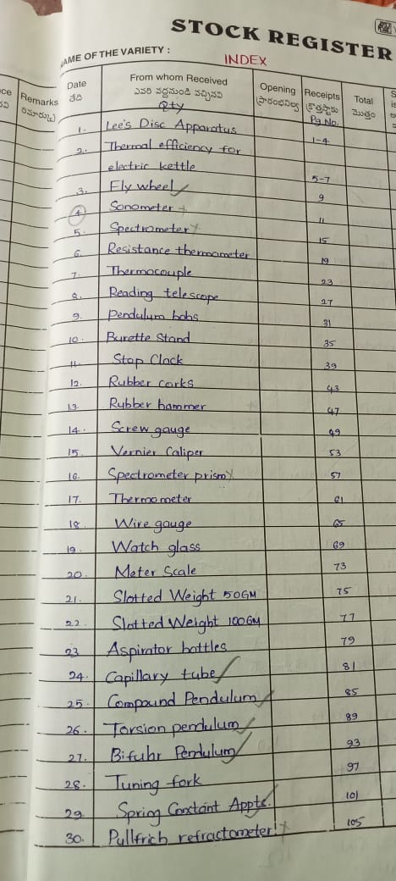

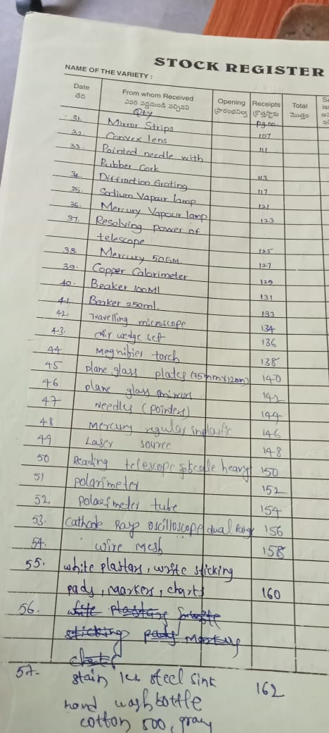

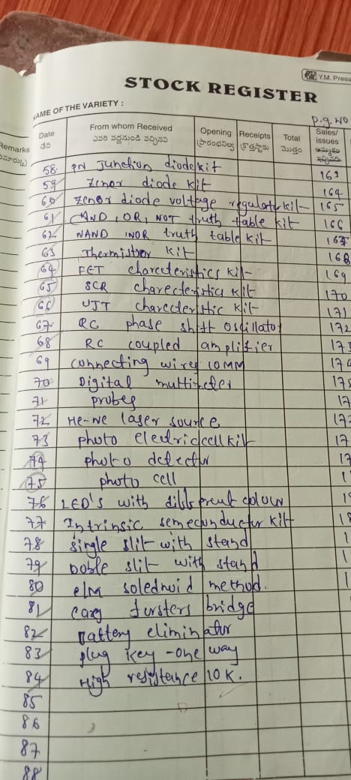

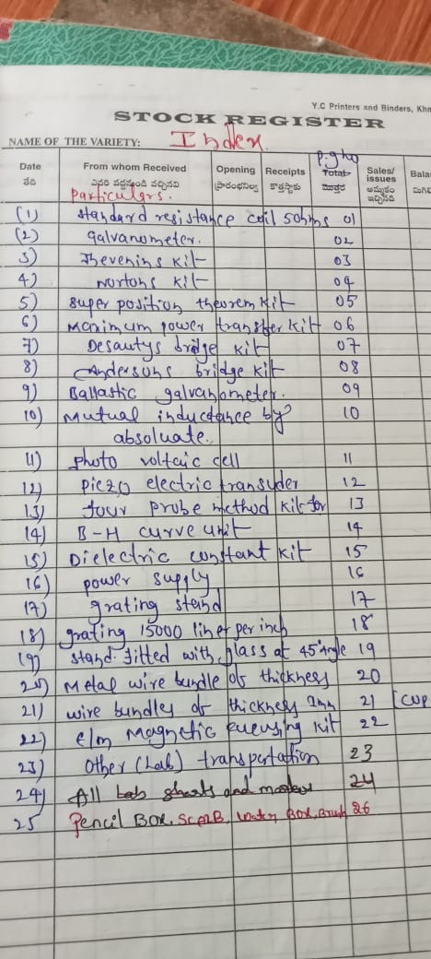

#### FURNITURE

**DEPARTMENTALLIBRARY**

DepartmentofZoologyhasaLibrarywith10referencebooks,04Nospractical Manuals and 02 Nos PG entrance books .

|  |  |  |
| --- | --- | --- |
| S.no | BOOKS | No |
| 1 | ReferenceBooks | 10 |
| 2 | PracticalManuals | 04 |
| 3 | PGentranceBooks | 02 |

**CRITERIA –V STUDENT SUPPORTIVE AND**

**PROGRESSION.**

|  |  |  |  |  |  |
| --- | --- | --- | --- | --- | --- |
| **S.No** | **Name of**  **student** | **Graduate**  **from** | **PG/B.Ed** | **year** | **Institute**  **name** |
| **1**  **2** | **V.LAXMIPRABHA**  **A.MAMATHA SRI** | **B.sc**  **B.sc** | **M.Sc.,**  **M.Sc.,** | **2020-21**  **2020-21** | **OSMANIA UNIVERSITY**  **OSMANIA UNIVERSITY** |
| **3** | **CH.SRINAVYA** | **B.sc** | **M.Sc.,** | **2020-21** | **OSMANIA UNIVERSITY** |
| **4** | **A.PRAVALIKA** | **B.sc** | **M.Sc.,** | **2021-22** | **OSMANIA UNIVERSITY** |
| **5** | **M.SANDHYA** | **B.sc** | **M.Sc.,** | **2021-22** | **NIZAMCOLLEGE**  **OU,HYD** |
| **6** | **D.ANITHA** | **B.sc** | **M.Sc.,**  **GEOPHYSICS** | **2021-22** | **OSMANIA UNIVERSITY** |
| **7** | **S.SONIYA** | **B.sc** | **M.Sc.,**  **ELECTRONICS** | **2021-22** | **TELANGANA UNIVERSITY** |
| **8** | **K.KRISHNAVENI** | **B.sc** | **M.Sc.,(electronics and communication)** | **2023-24** | **NIZAM COLLEGE** |
|  |  |  |  |  |  |
|  |  |  |  |  |  |
|  |  |  |  |  |  |
|  |  |  |  |  |  |

**CRITERIA-VI**

**GOVERNANANCE LEADERSHIP AND MANAGEMENT**

#### DEPARTMENTALMEETINGS

**At the departmental level, Department faculty members meet at necessary days to discuss academic matters like Distribution of syllabus among the faculty review of coverage of syllabus and result analysis and course out comes**

**,important date to celebrate,etc,.**

|  |  |  |  |
| --- | --- | --- | --- |
| **S.NO** | **ACADEMICYEAR** | **NAMEOFTHE DEPARTMENT**  **INCHARGE** | **DESIGNATION** |
| **1** | **2017-18** | **M.NAGASRI** | **LECTURER** |
| **2** | **2018-19** | **K.MANASA** | **LECTURER** |
| **3** | **2019-20** | **K.MANASA** | **LECTURER** |
| **4** | **2020-21** | **B.HAREESH** | **LECTURER** |
| **5** | **2021-22** | **B.HAREESH** | **LECTURER** |
| **6**  7  8 | **2022-23**  **2023-24**  **2024-25** | **B.HAREESH**  **B.HAREESH**  **A.SWARNAKUMARI** | **LECTURER**  **LECTURER**  **LECTURER** |

**CRITERIA- VII**

**INSTITUTIONAL VALUES AND BEST**

**PRACTICES**

**INSTITUTIONALVALUES AND BESTPRACTICES**

**.**

**BEST PRACTICES.**

1. In addition to the regular courses, our department offers Certificate and value added Courses.

2. Academic and Administrative Audit is conducted by an external expert to audit Teaching-Learning Process, infrastructure and research of the department every year.

3. Students are encouraged to give presentation so that they will learn the subjects thoroughly in addition to improving their communication and presentation skills.

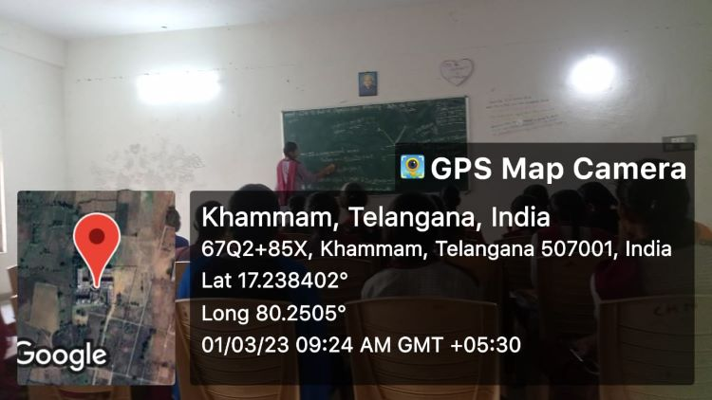

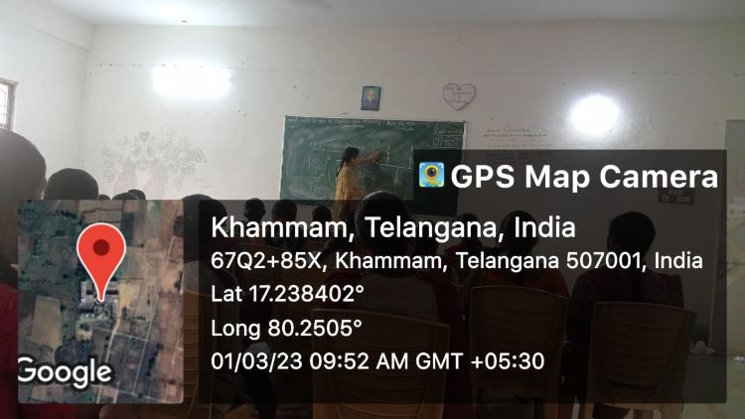

**Group discussions and Debates**:-

Department of Physics organized the group discussion for the BSc final year students keeping in the point of view to express their knowledge in a group. Department allotted the some topics in the syllabus of the BSc final year to the group of the students and told him to express their own view up to the one minute and then you had given the 5 minutes to discuss the topic in a group and finally one of them from you give the final conclusion regarding the Topics. 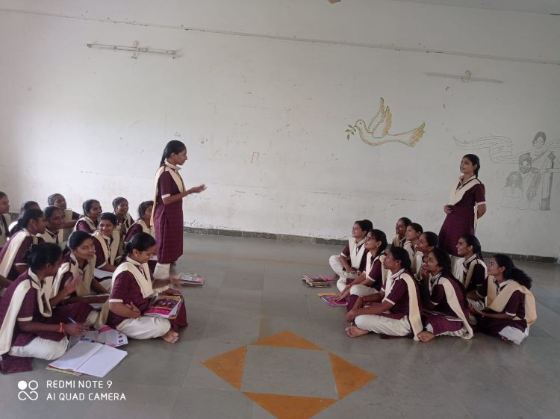

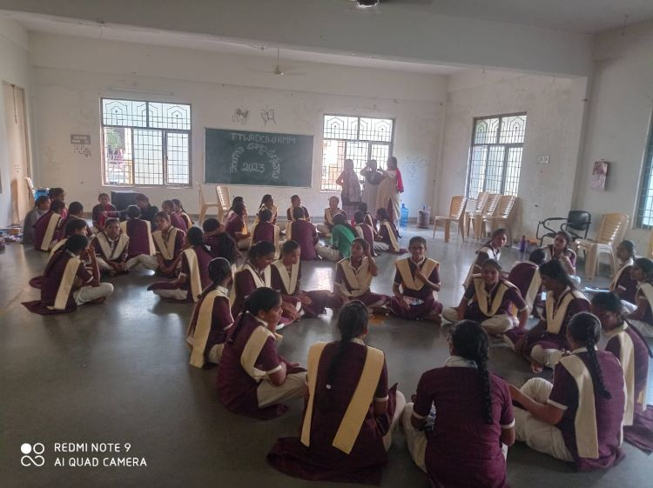

**Coaching for CPGET and IIT - JAM.**

**OBJECTIVES OF THE PRACTICE:**

Most of the students are interested to do their Post-Graduation in Physics but they are not in a proper planning due to lack of guidance. Keeping this in mind, our department is encouraging those students and offering coaching classes after their regular classes every year. As a result of our effort, many students got good ranks and joined university campuses and premiere institutions every year.

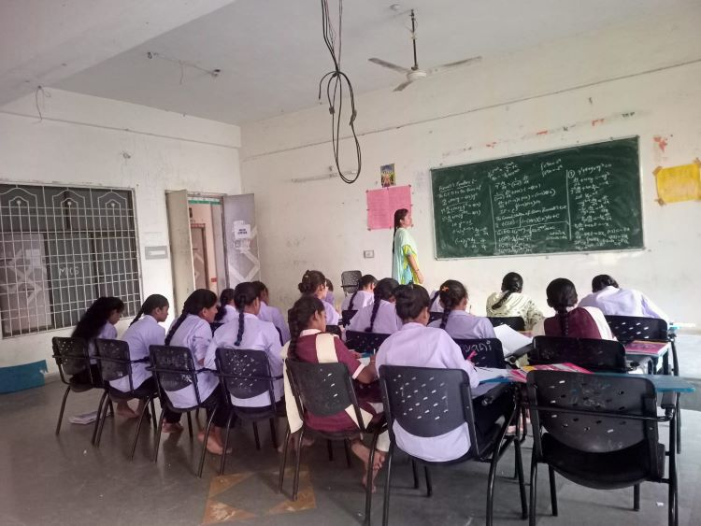

We told the students that they do not get good employment opportunities only by doing graduation and encouraged them to complete their masters. We motivated the students who are good at Mathematics to prepare for various PG entrance examinations and supported them with free entrance coaching.

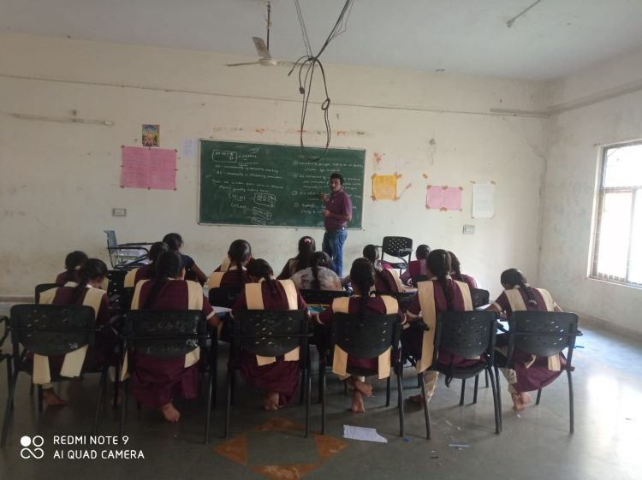

**ACTION TAKEN**:

We have identified the students who have good Analytical skills and motivated them to do M.Sc. Physics. We assured them to offer free coaching for various entrances and planned for the schedule. We have registered the students and conducted classes as per schedule. We also provided material and conducted model examinations. As a result of our effort, many students got good ranks and joined university campuses and premiere institutions.

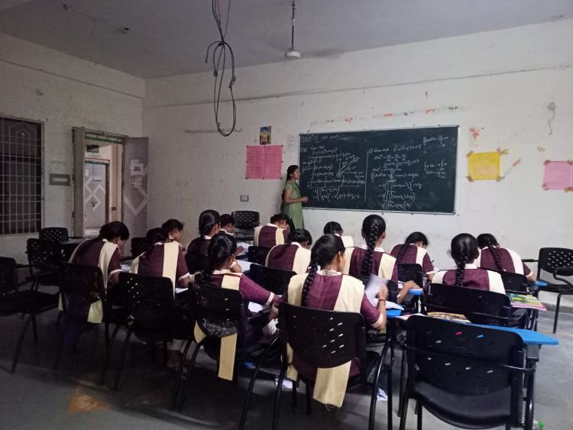

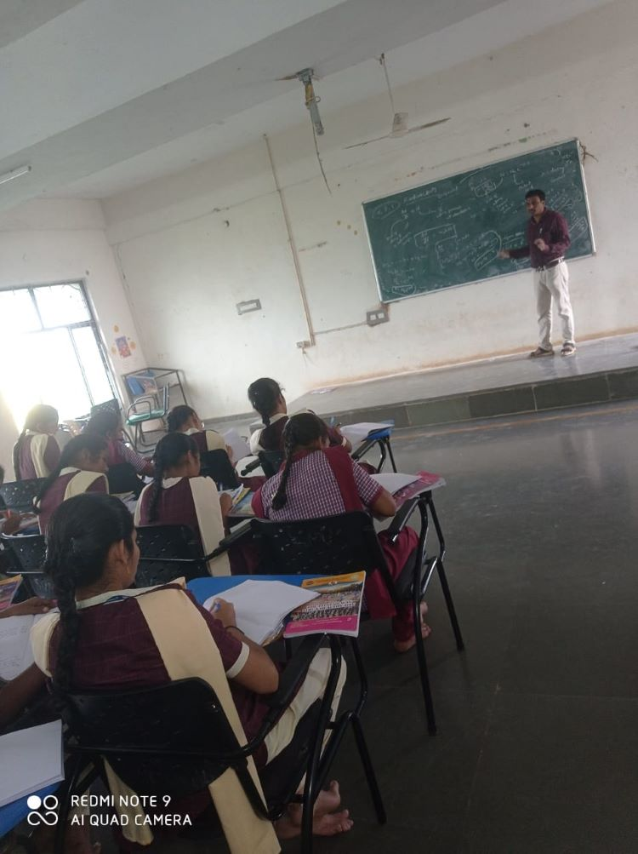

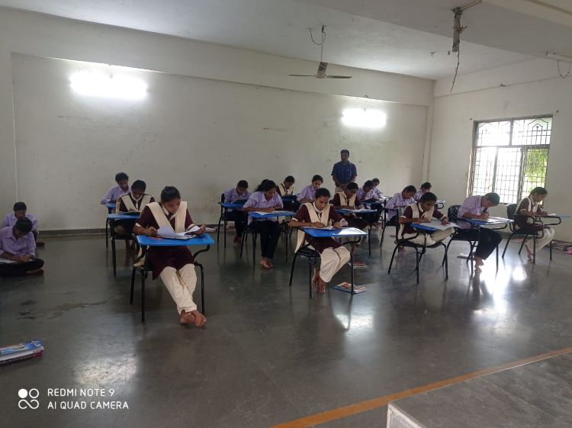

**P.G STUDENT LISTS:**

Department of Physics started free coaching started coaching from 2020-21,. Classes we conducted The following students are attended for PG Coaching and Got Admitted in Various Institutions.

|  |  |  |  |  |  |  |
| --- | --- | --- | --- | --- | --- | --- |
| Sl.No | Ht.No | NAME OF THE STUDENT | GROUP | Rank in CPGET | YEAR | Admitted Institution(M.Sc Physics) |
| 1 | 69024290018 | V.Laxmi Prabha | lll MPCS | 22 | 2021 | OU Campus, Hyderabad. |
| 2 | 69024290017 | Ch.Srinavya | III MPCS | 246 | 2021 | OU Campus, Hyderabad. |
| 3 | 69024290069 | A.Mamatha Sri | III MPCS | 283 | 2021 | OU Campus, Hyderabad |
| 4 | 69093770491 | T.Mankisha | III MPCS | 507 | 2021 | KU Campus,Warangal |
| 5 | 69033350018 | M.Sandhya | III MPCs | 118 | 2022 | Nizam College Campus, Hyderabad. |
| 6 | 69033350019 | DS.Anitha | III MPC | 243 | 2022 | OU Campus, Hyderabad |
| 7 | 69033350006 | A.Pravalika | III MPCS | 329 | 2022 | KU Campus,Warangal |
| 8 | 69033350115 | M.Ramya | III MPCS | 500 | 2022 | MG University, Nalgonda. |
| 9 | 69033350015 | S.Soniya | III MPC | 715 | 2022 | TG University Campus, Nizamabad |
| 10 | 69033350044 | K.Padmavathi | III MPC | 912 | 2022 | Admitted in B.Ed |
| 11 | 69033350032 | M.Dhanalaxmi | III MPC | 1072 | 2022 | Admitted in B.Ed |
| 12 | 69033350022 | V.Ramadevi | III MPCS | 1235 | 2022 | PG Centre,Siddipet. |
| 13 | 69033350191 | D.Srilekha | III MPC | 1607 | 2022 | Admitted in B.Ed |
| 14 | 69080280513 | K.Krishnaveni | III MPC | 383 | 2023 | KOTI Womens’ College Campus, Hyderabad. |
| 15 | 69024050023 | K.Sravani | III MPCS | 1094 | 2023 | UPGC, Palamur University, Mahabubnagar. |

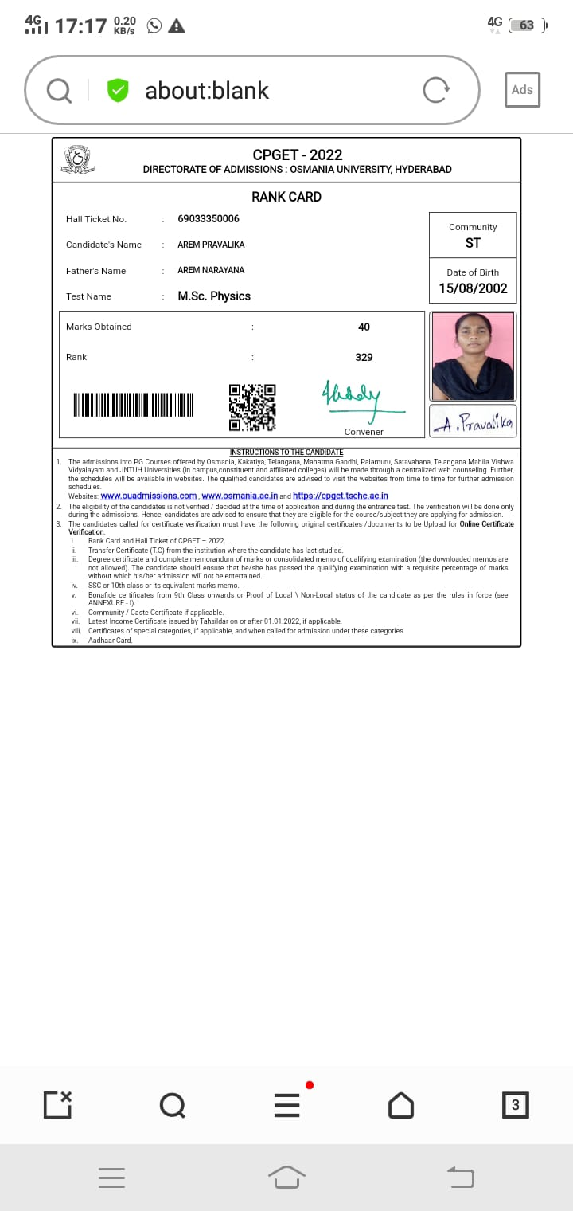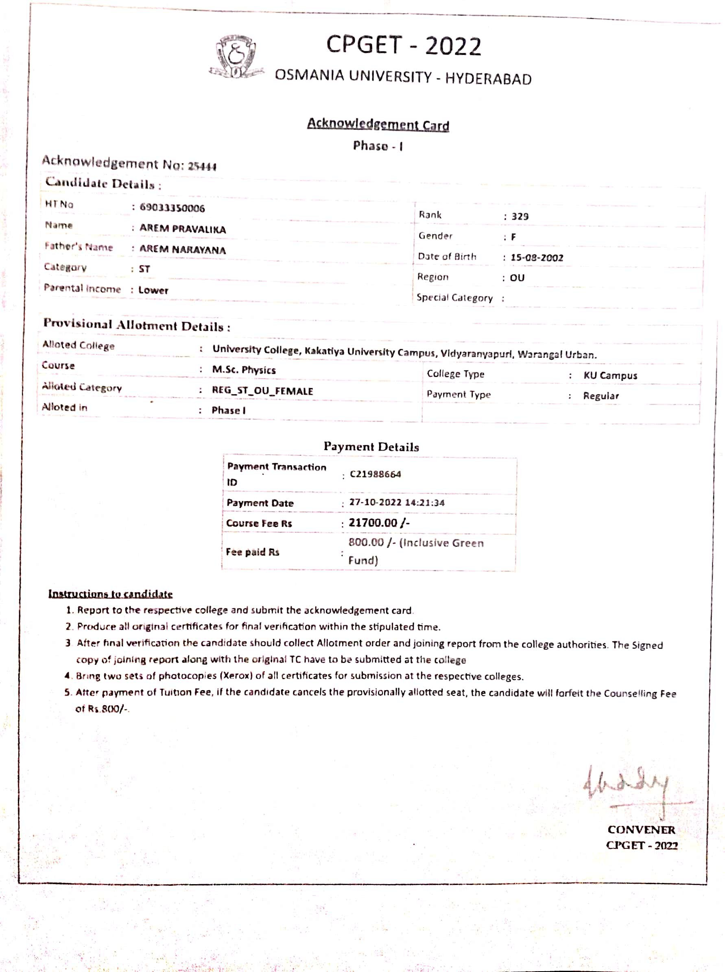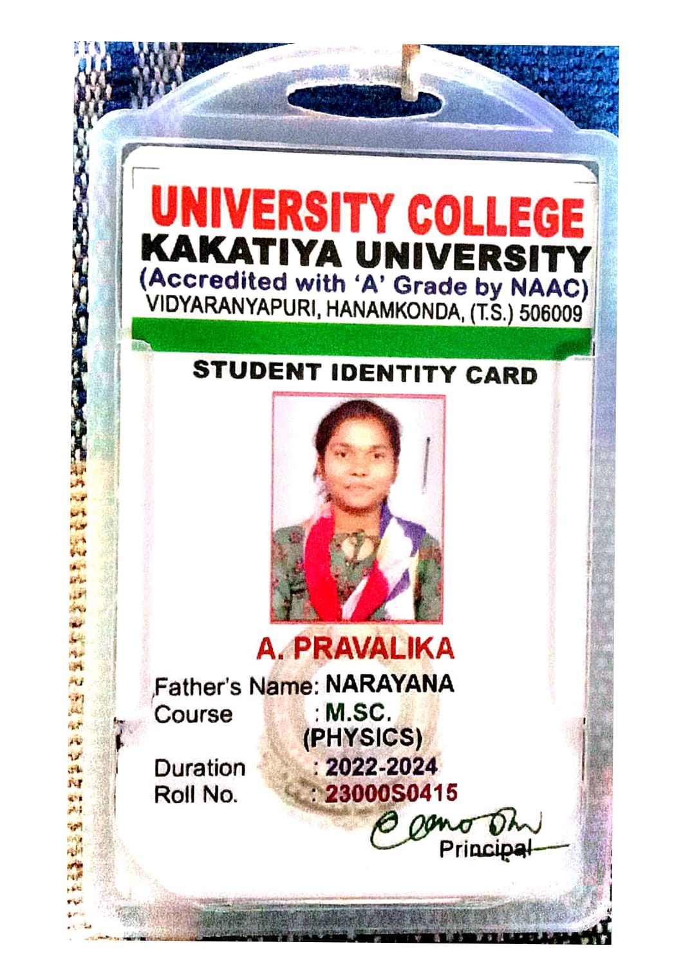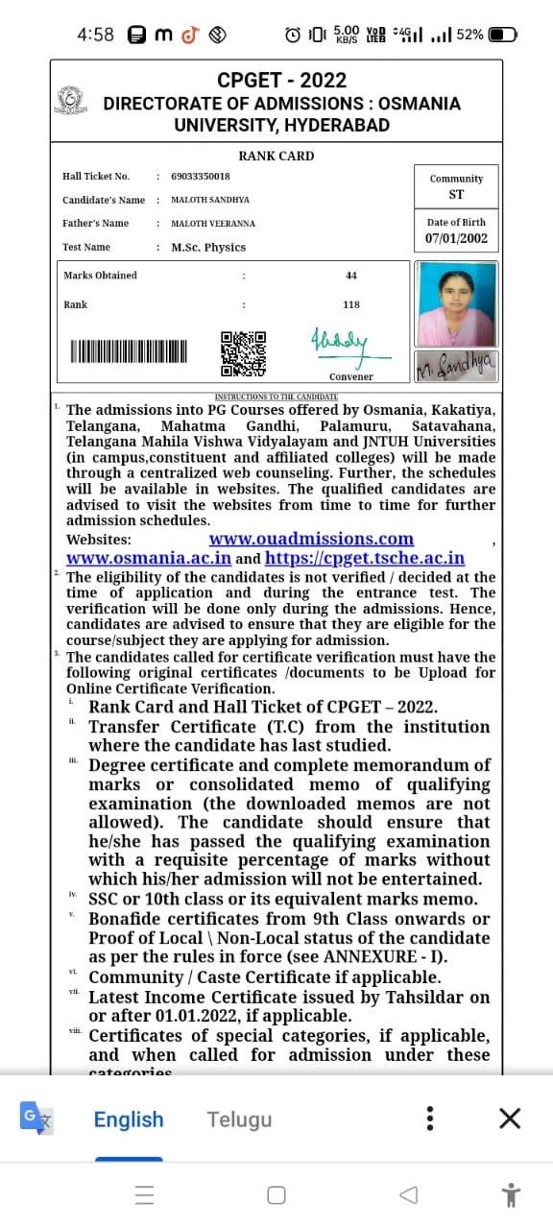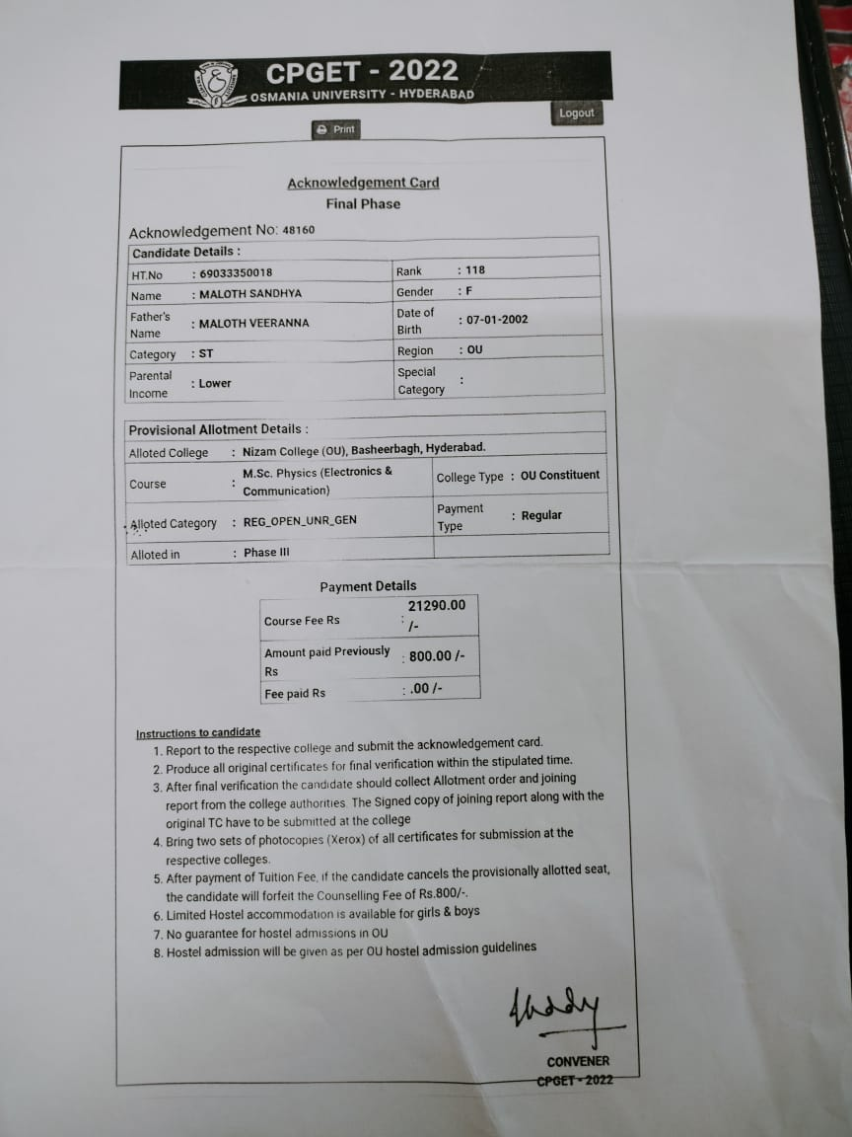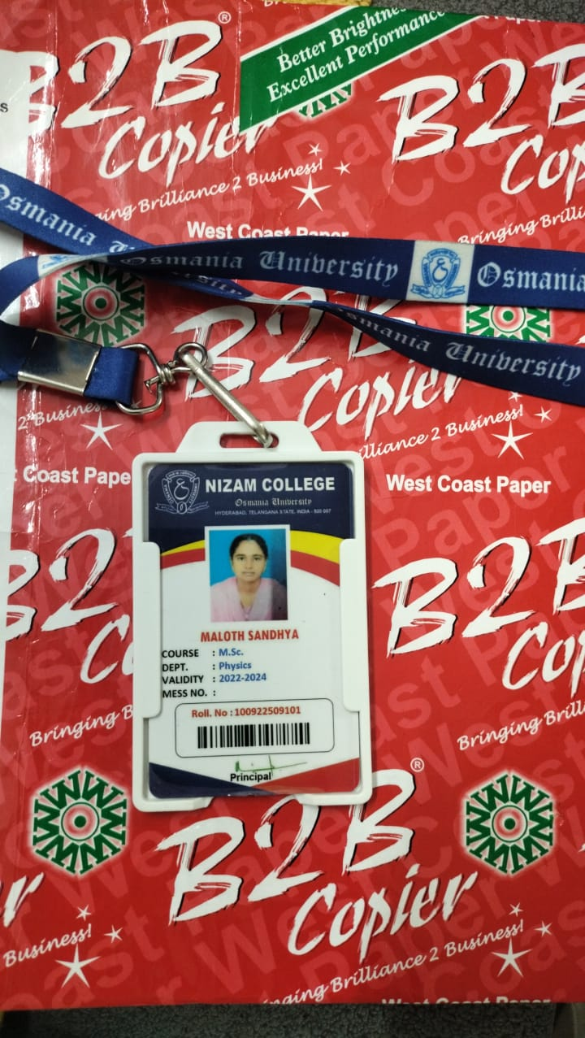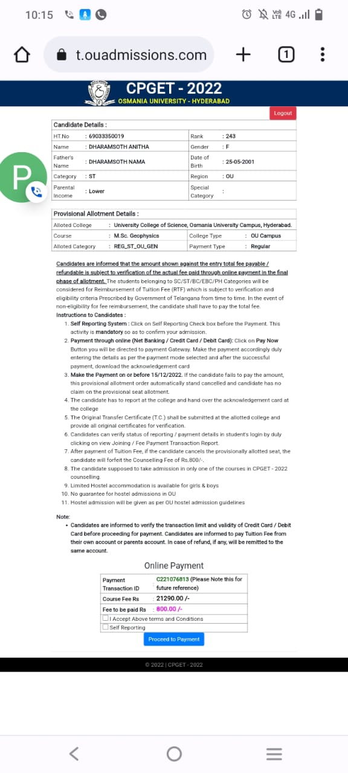

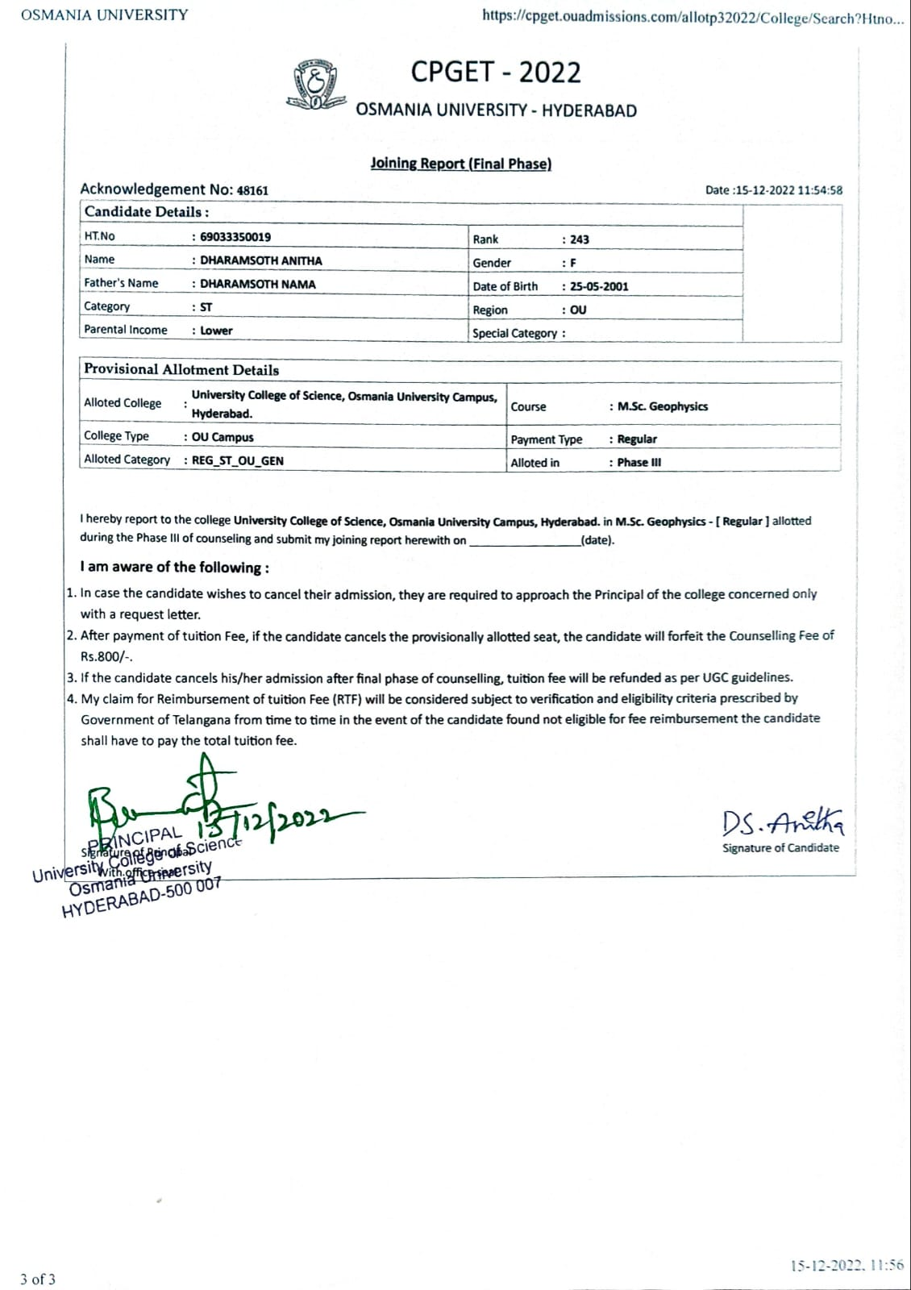

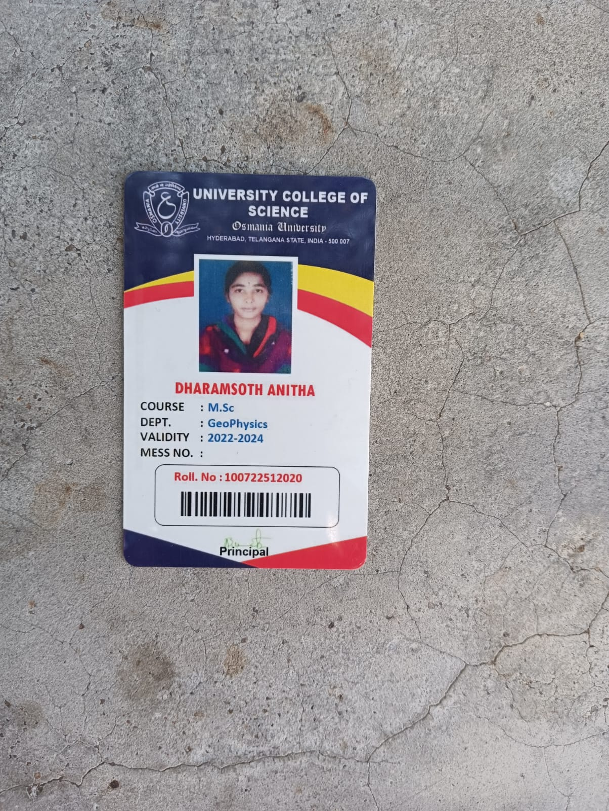

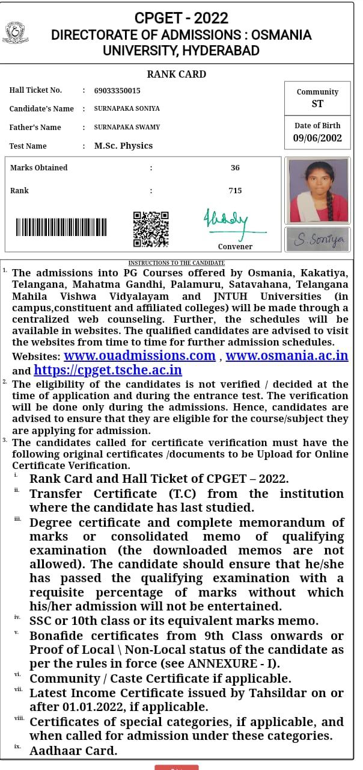

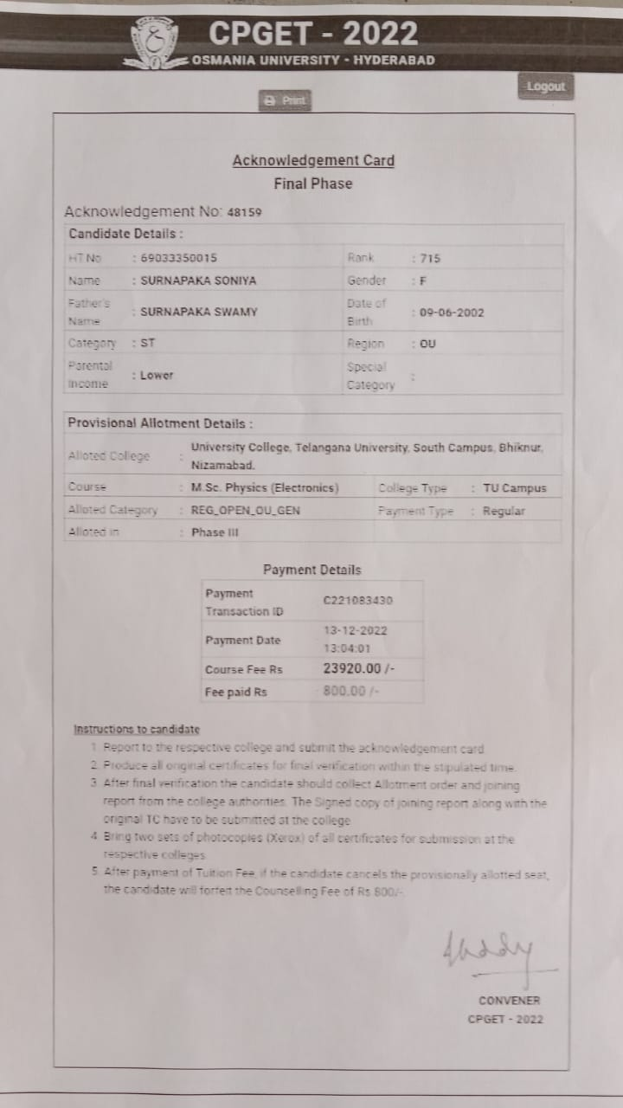

**/8**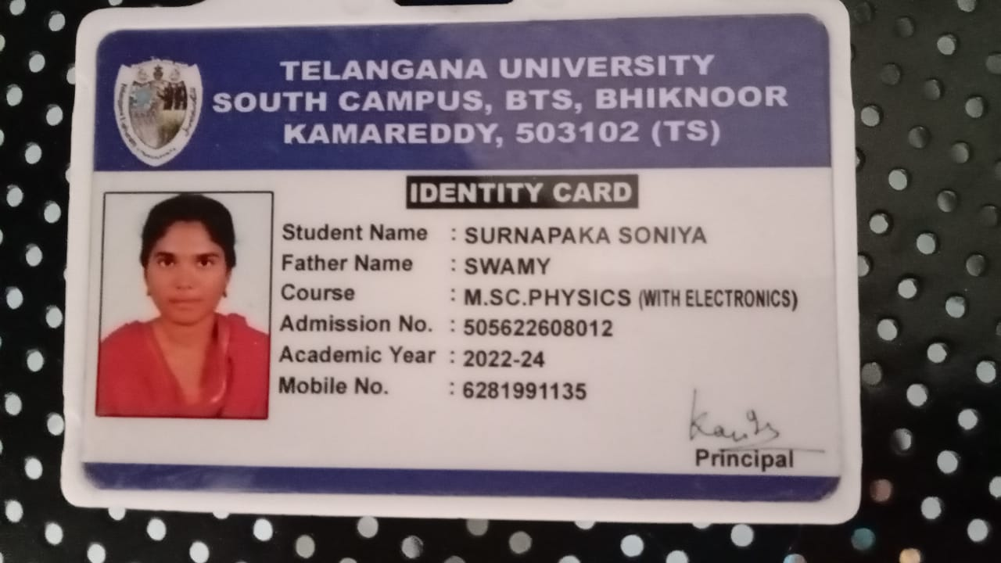

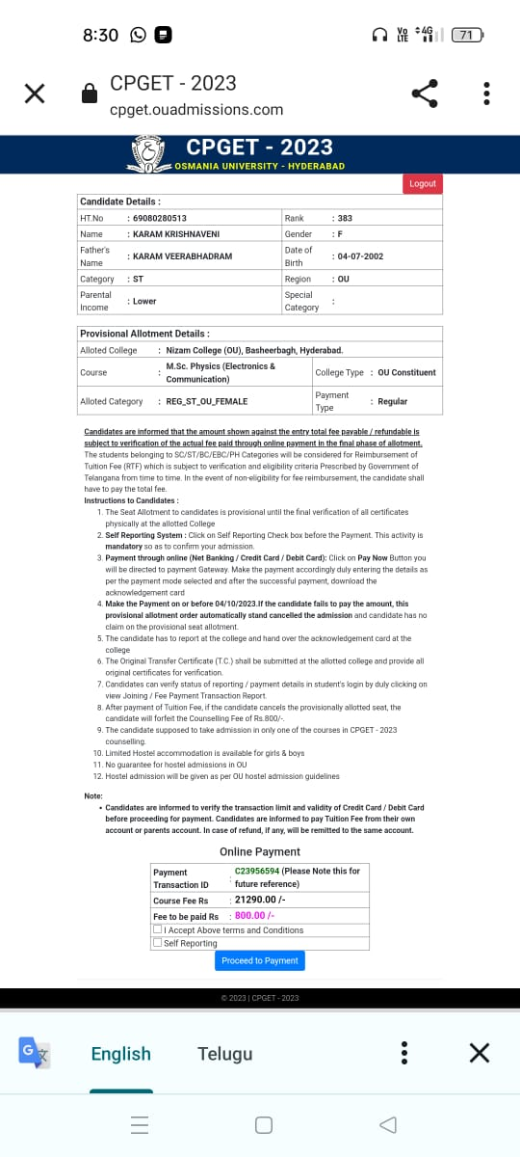

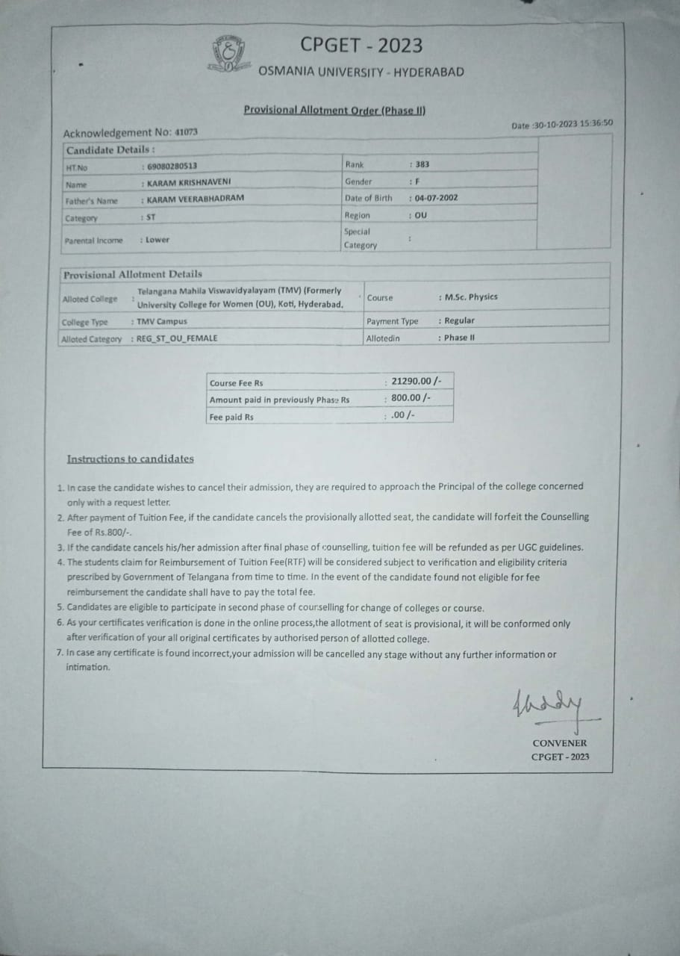

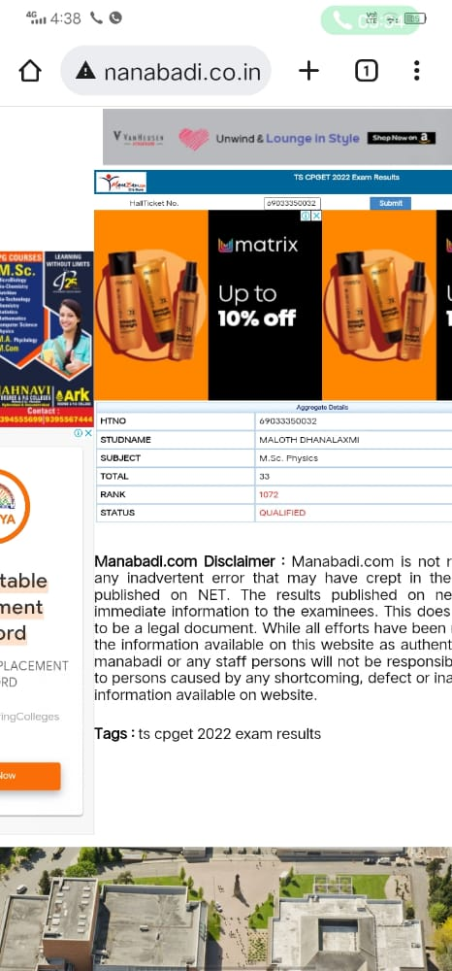

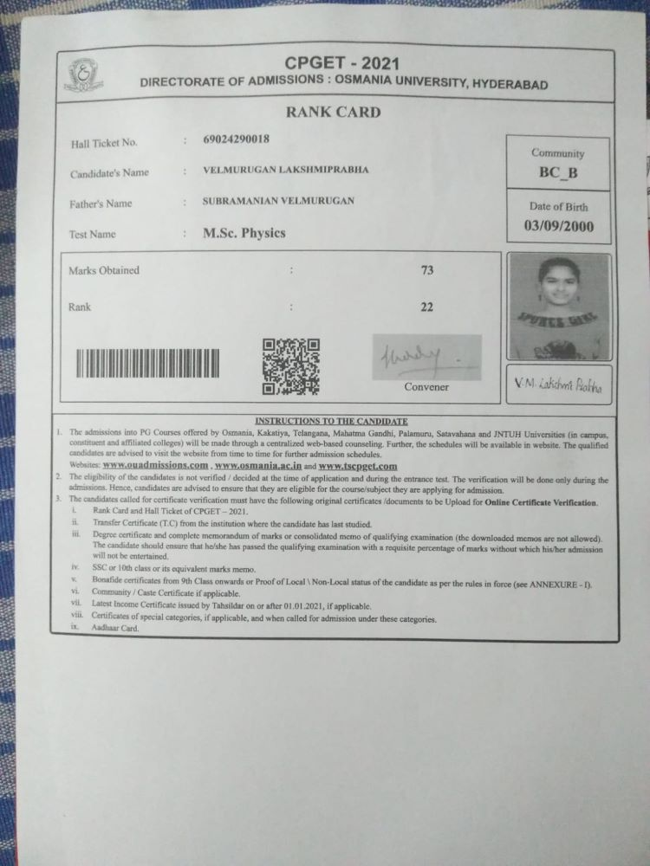

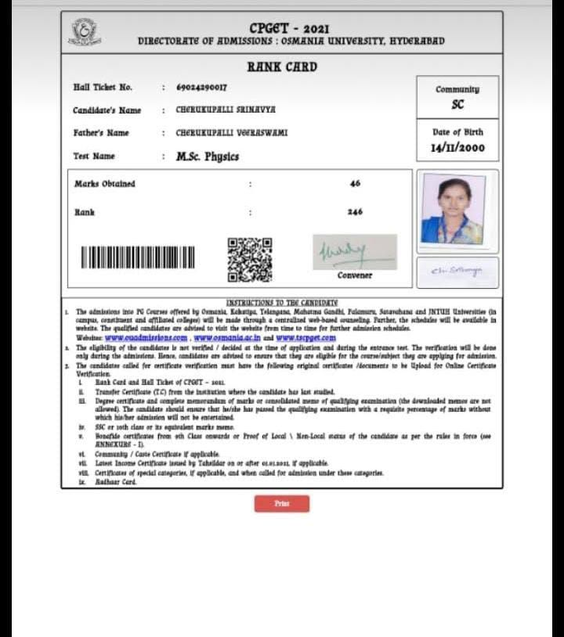

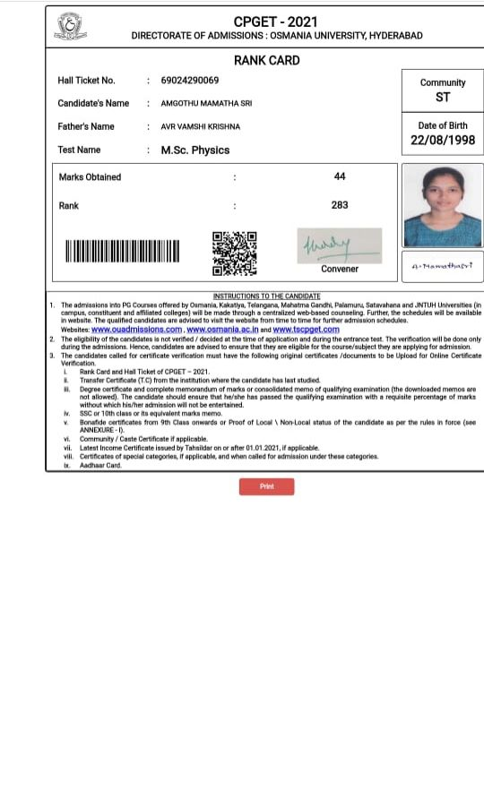

### FuturePlans.

* + Tostrengthenthedepartmentitisproposedtoapplyfor sanction of well equipped laboratory, well established Departmental Library and supervisory ship.
  + Todevelopinterdisciplinaryaddoncourses.
  + Tointensifyextracurricularactivityinthedepartment.
  + ParticipationinInstitutionalSocialResponsibilityand Extension activities.
  + Forquickandaccurateinternalevaluationofthestudent performance.

